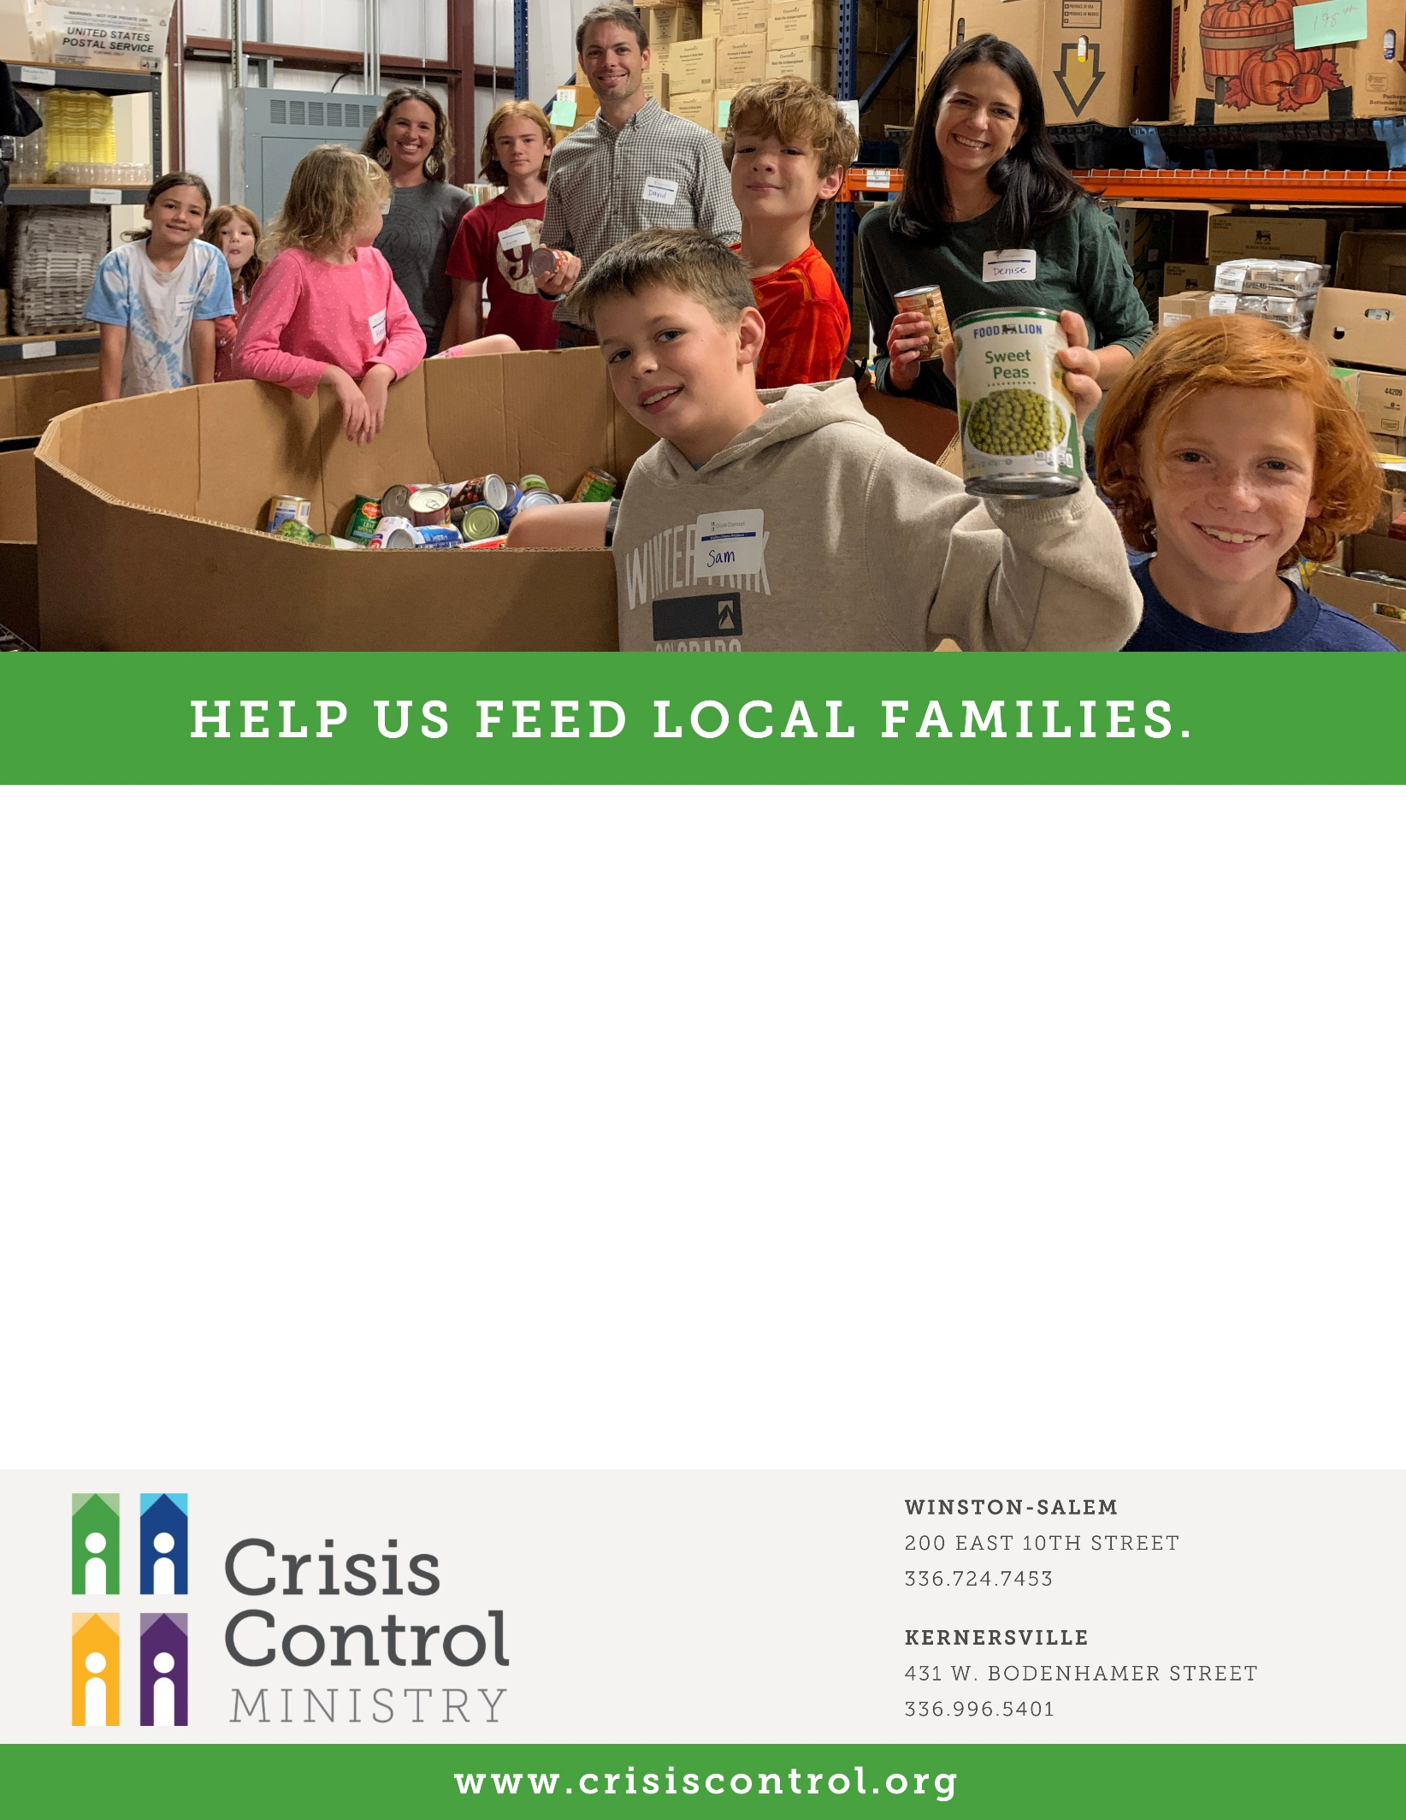

**FOOD DRIVE**

TO SUPPORT CRISIS CONTROL MINISTRY

**DATE**

**TIME**

YOUR LOCATION

AND INFORMATION